Downloading Photos
You can download photos on your own computer and bring them to class on a flash drive. Make sure that you put all the photos into a folder. Use photos from Flickr so that you get the right size and the proper permission to use them.

You can also download photos in the Mac Lab. Follow the directions for searching on Flickr. Make sure the photos you check Creative Commons-licensed Content so that you have permission to use the photos.

Downloading from Flickr
Here is a photo that I found on. Note that it is licensed under the Creative Commons. That means I can use it in my project.
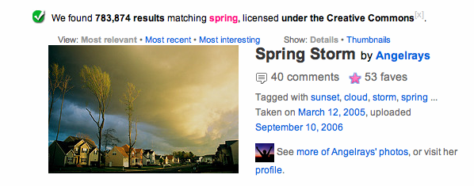
Double-click on the photo. Be patient and wait for the photo to load. You will see a bigger photo. At the top of the photo you will see ALL SIZES.
Click on ALL SIZES.

You will see an even bigger photo. Above the photo, you will see different sizes. Choose medium. The photo will change to medium size. Then click on Download Medium size.

Now use the back arrow and go back to the photos page. You can continue your search, or you can start a new one.

In the Mac Lab, you will find your photos in the Downloads folder.
Double-click on the Macintosh HD icon on your computer desktop.

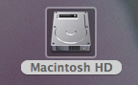

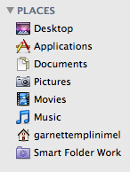

You will see Places. Click on your name. In this example, I will select, “garnettemplinimel,” my name. You will see the Downloads folder.

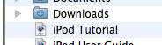 Click on Downloads and you will find your photo. The photo has a long number with .jpg at the end. Select the photo and drag it to the computer desktop. You can select the title and change it if you want to. Leave .jpg at the end. You can then drag it into your Photos folder.

Making an album in iPhoto

Click on the iPhoto icon on the dashboard at the bottom of the computer screen.
Go to FILE > IMPORT TO LIBRARY at the top. Select your photo folder. All photos in the folder will import into iPhoto. My folder is Seasons Photos.

Next go to FILE > NEW ALBUM.
Name your new album. Click create.
Your new album will appear on the left side in iPhoto.
Next click on Last Import above ALBUMS. You will see all your photos. Drag them to your ALBUM. You are done. Close iPhoto.

